Predict insurance charges and remove outliers

Code:
import pandas as pd
import numpy as np
import matplotlib.pyplot as plt
import seaborn as sns
from sklearn.model_selection import train_test_split
from sklearn.metrics import accuracy_score
from sklearn.neighbors import KNeighborsClassifier
from sklearn.linear_model import LinearRegression
from sklearn.metrics import mean_squared_error, r2_score
df = pd.read_csv("predict insurance charges.csv")
df.head()
df.info()
df.describe()
df.isnull().sum()
df = pd.get_dummies(df, drop_first=True)
df.head()
plt.figure(figsize=(6,4))
sns.boxplot(x=df['charges'])
plt.title("Boxplot of Charges")
plt.show()
Q1 = df['charges'].quantile(0.25)
Q3 = df['charges'].quantile(0.75)
IQR = Q3 - Q1
lower = Q1 - 1.5 * IQR
upper = Q3 + 1.5 * IQR
df = df[(df['charges'] >= lower) & (df['charges'] <= upper)]
df['charges'].hist(bins=30)
plt.title("Charges Distribution")
plt.show()
plt.figure(figsize=(10,6))
sns.heatmap(df.corr(), annot=True, cmap='coolwarm')
plt.show()
X = df.drop('charges', axis=1)
y = df['charges']
X_train, X_test, y_train, y_test = train_test_split(
X, y, test_size=0.2, random_state=42
)
model = LinearRegression()
model.fit(X_train, y_train)
y_pred = model.predict(X_test)
new_data = pd.DataFrame({
'age': [30],
'bmi': [25.0],
'children': [1],
'sex_male': [1],
'smoker_yes': [0],
'region_northwest': [0],
'region_southeast': [0],
'region_southwest': [1]
})
new_data = new_data.reindex(columns=X.columns, fill_value=0)
model.predict(new_data)
mse = mean_squared_error(y_test, y_pred)
r2 = r2_score(y_test, y_pred)
print("MSE:", mse)
print("R2 Score:", r2)
knn_model = KNeighborsClassifier(n_neighbors=5)
knn_model.fit(X_train, y_train_class)
y_pred_knn = knn_model.predict(X_test)
print("KNN Accuracy:", accuracy_score(y_test_class, y_pred_knn))

output:

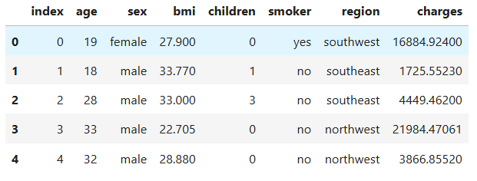
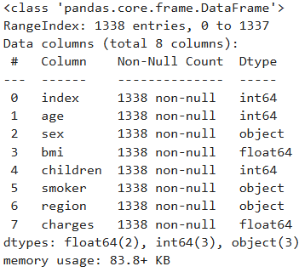
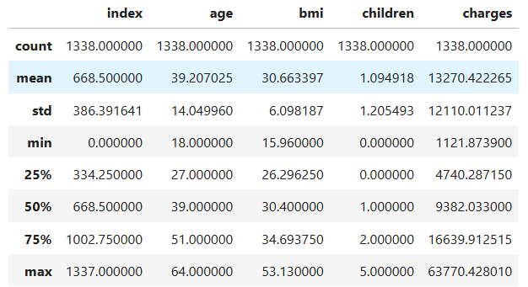

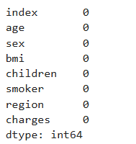

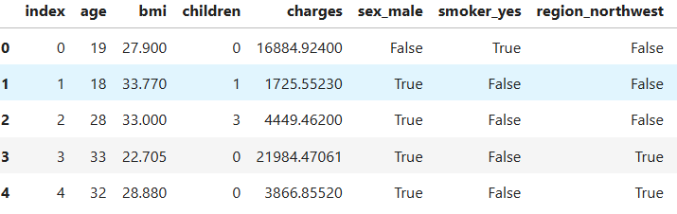
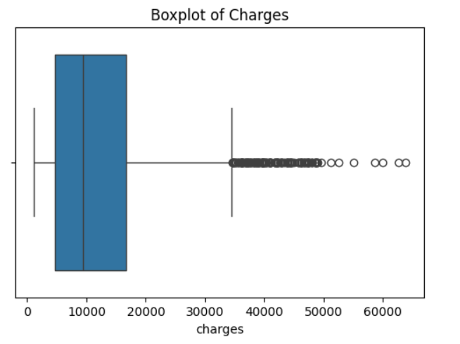

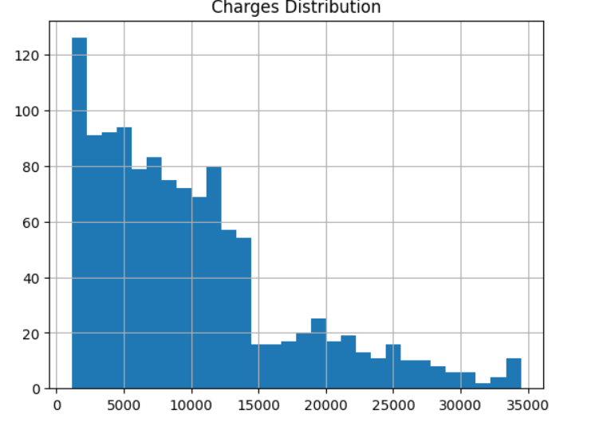
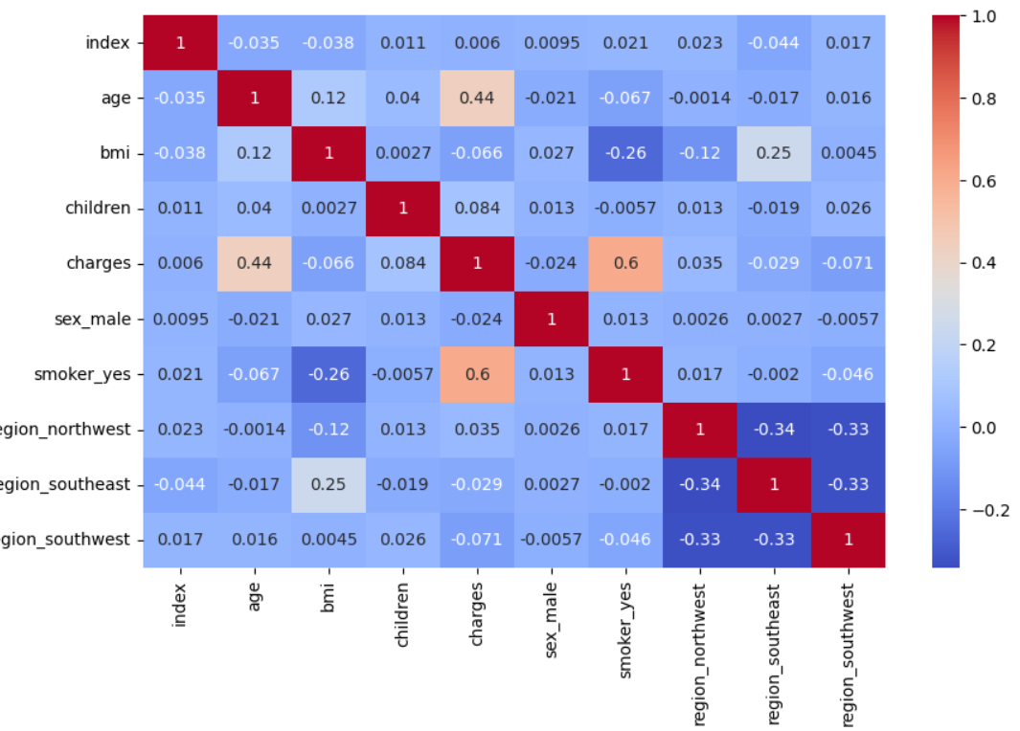
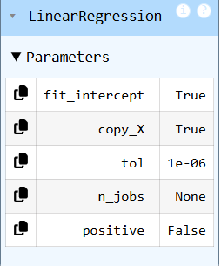
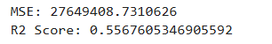
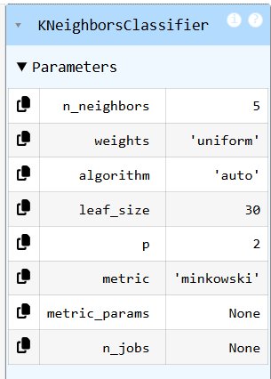

Algorithm used:
To predict insurance charges, we used Linear Regression and K-Nearest Neighbors (KNN) algorithms, which help in estimating continuous values based on input features like age, BMI, and smoker status. Before applying these models, we performed outlier removal using the Interquartile Range (IQR) method to eliminate extreme values in the dataset. Removing outliers helps in reducing noise and improving the quality of the data. This allows the models to learn better patterns and make more accurate predictions. As a result, the overall performance and reliability of the prediction model were improved.
Why you choose it:
We chose Linear Regression because it is simple, easy to understand, and works well for predicting continuous values like insurance charges. It helps in identifying the relationship between input features and the target variable. We also selected K-Nearest Neighbors (KNN) because it can capture non-linear patterns and improves prediction by considering similar data points. Additionally, we used the IQR method for outlier removal because it is an effective and simple statistical technique to detect and eliminate extreme values. These choices help in improving the accuracy and overall performance of the model.
Result obtained:
After removing outliers using the IQR method and applying Linear Regression and K-Nearest Neighbors (KNN), we obtained improved prediction results for insurance charges. The error values were reduced, and the model showed better accuracy compared to using raw data. Among the models, Linear Regression provided stable and consistent results, while KNN captured some non-linear patterns. Overall, outlier removal helped in enhancing model performance and produced more reliable predictions.

